Protocol / Statistical Analysis Plan –
The effect of COVID-19 on Preconception Health among Individuals who Require an Interpreter in England

Version Control
Disposition
Subject | Protocol / Statistical Analysis Plan
Title | CVD-COVID-UK / COVID-IMPACT Data: The effect of COVID-19 on Preconception Health among Individuals who Require an Interpreter in England
Version | 2_0
Date of this version | 23rd May 2025
Scheduled for review | November 2025
Status | DRAFT
Information Classification | NORMAL


LONDON’S GLOBAL UNIVERSITY

Ownership
Author | Dr Majel McGranahan
Owner | Institute of Health Informatics (IHI)
Organisation | University College London

Version Control
V1_0 | 29/05/23 | Draft finalised by M McGranahan
V2_0 | 23/05/25 | Draft finalised by M McGranahan

University College London, Gower Street, London WC1E 6BT
Tel: +44 (0)20 7679 2000 www.ucl.ac.uk
The effect of COVID-19 on Preconception Health among Individuals who Require an Interpreter in England

Lay Summary & Background
Lay Summary
The research team will use the CVD-COVID-UK / COVID-IMPACT Data to explore how the COVID-19 pandemic affected preconception health among women whose first language isn’t English and require an interpreter in England. Many of these individuals are likely to be from underserved migrants backgrounds.
One in three births in England and Wales is to a migrant woman, i.e. a woman who was born outside the UK. A woman's health before pregnancy affects her health during and after pregnancy, as well as her baby’s health. In the UK, underserved migrant women (such as refugees, asylum seekers and migrant women without an official visa) are more likely to die in pregnancy, and they are less likely to get good pregnancy care. There are many reasons for poor health before and during pregnancy amongst underserved migrant women including not having support to access the NHS, not having family nearby, not speaking English well, and experiencing discrimination. These women are likely to have experienced poorer NHS care during the COVID-19 pandemic which is likely to have affected their health before pregnancy including access to contraception from the GP. We hope to use the CVD-COVID-UK / COVID-IMPACT Data to better understand how the pandemic impacted women’s health before getting pregnant including access to contraception.

Background
With over one billion people on the move globally, the healthcare of international migrants is increasingly important in the design and delivery of health services. COVID-19 has had a greater impact on minority ethnic populations and migrants in England. Women of reproductive age have specific health needs that need to be addressed, and an estimated 1 in 3 women giving birth during the pandemic were from a migrant background, i.e. not born in the UK. However, we do not know how COVID-19 has affected preconception health, or how being a migrant or belonging to a particular ethnic group may lead to inequalities in COVID-19 outcomes. The need for interpretation services is a good way to identify if someone is an international migrant as evidenced by data from the Migration Observatory which indicate that 99% of people born in the UK consider English as a first language (Figure 1). Therefore, there is a very small chance that individuals requiring an interpreter are UK-born.
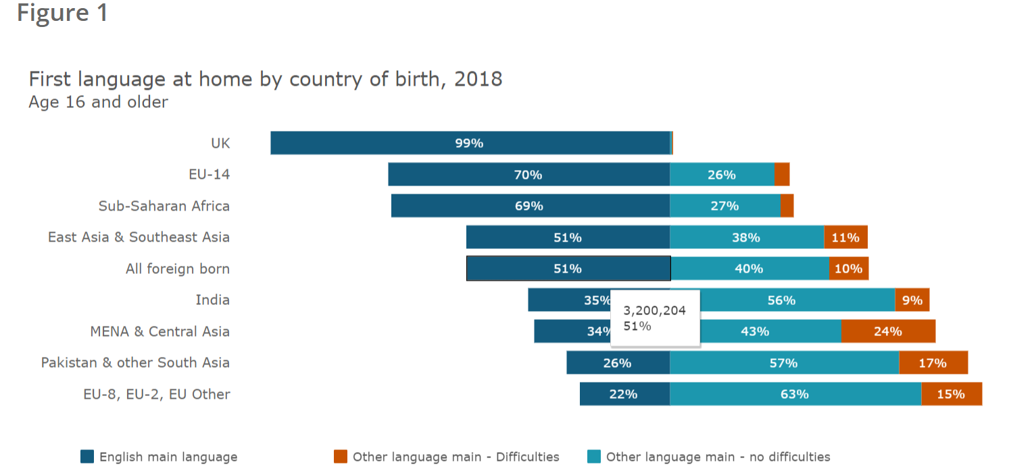
Source: The Migration Observatory. https://migrationobservatory.ox.ac.uk/resources/briefings/english-language-use-and-proficiency-of-migrants-in-the-uk/

Considering that there are 968,190 individuals within NHS Digital Trusted Research Environment that have interpreter codes, this linked data source presents an ideal format and unique opportunity to enable us to understand the impact of COVID-19 on migrant preconception health, thus supporting the principles and aims of the COVID-IMPACT project. Whilst we recognise that this may not capture all migrants, we believe that individuals whose first language isn’t English and require an interpreter represent some of the most underserved migrant groups with the greatest needs in terms of healthcare access barriers and challenges.

In summary, this research will highlight the direct and indirect impact of the COVID-19 pandemic on migrant preconception health, thus aligning directly with the aims of COVID-IMPACT.

2. Research Plan

2.1 Research Hypothesis
We hypothesise that women whose first language is not English will have poorer preconception health during the COVID-19 pandemic compared to women whose first language is English.

2.2 Aim & Research Questions
Aim: The aim of this study is to explore the impact of the COVID-19 pandemic on preconception health among individuals whose first language isn’t English and require an interpreter in England.

Research Questions:
- What are the demographics and indicators of preconception health among women whose first language isn’t English and who used an interpreter before and during the COVID-19 pandemic?
- How has COVID-19 influenced preconception morbidity and mortality including healthcare resource utilisation and vaccination uptake among individuals whose first language isn’t English and require an interpreter in England versus those who don’t require an interpreter?

  - Datasets
Trusted Research Environments (TRE):
NHS Digital TRE for England

Data Sources:
-GDPPR
-HES (Admitted patient care, maternity, outpatients, A&E)
-Vaccination status
-Civil registration – deaths
-Medicine dispensed in primary care
-Maternity Services Dataset (MSDS)

Reasons Required:
These datasets will enable us to get a broad view of the impact of the COVID-19 pandemic on children whose first language isn’t English and who require an interpreter in England.

  - Study Design & Study Population

This is an observational, retrospective longitudinal cohort study comparing preconception health before and after the COVID-19 pandemic among individuals who have used an interpreter within primary care and those who have not used an interpreter. Among individuals born in the UK, 99% speak English as a first language at home (https://migrationobservatory.ox.ac.uk/resources/briefings/english-language-use-and-proficiency-of-migrants-in-the-uk/), so interpreter use is a good proxy for being born outside the UK (i.e. being a migrant).

Definition of the study population
The ‘exposed’ study population will include:
- Women of reproductive age (18-49 years) who have use of interpreter recorded

The ‘unexposed’ study population will include:
- Women of reproductive age (18-49 years) who do not have use of interpreter recorded

We will adjust for confounding factors such as Index of Multiple Deprivation (IMD) quintiles and ethnic group during regression analysis. Where possible, and for frequent outcomes, we will also try to match controls by age and geographical location (e.g. using general practice or region in England). We will undertake sub-group analysis including women who have one or more pregnancies recorded during the study period where relevant.

Outcomes
Primary outcomes:
Health resource utilisation related to preconception health:
- Number of distinct Record_Dates for a patient within GDPPR
- Prescriptions
- Vaccinations
- Referrals to secondary care
- Diagnosis of existing health conditions
- New diagnosis of COVID-19 related conditions
- Preconception health indicators and outcomes (Maternity Services Data Set)
- Hospital (inpatient, outpatient, A&E) attendances (HES variables)
- Hospital admission (inpatient) (HES variables)
- Duration of hospital admission (HES variables)
- 30-day emergency readmissions (HES variables)
- Missed outpatient appointments (HES variables)
- Missed procedures (HES variables)
Secondary outcomes:
- All-cause mortality
- Cause-specific mortality (by ICD-10 chapter)
- Avoidable, amenable and preventable mortality

  - Statistical Methods

We will summarise preconception health and patterns of healthcare resource utilisation (including use of contraception as this is an indicator of preconception health) using the non-interpreter population as a reference. We will compare indicators and outcomes before and after COVID-19 public health interventions commenced in the UK (March 2020-ongoing). Logistic regression analyses will be used to generate odds ratios, and 95% confidence intervals. We will adjust for confounding factors within regression analyses. Where relevant, we will undertake sub-group analysis among women who have one or more recorded pregnancies within our study period to further explore indicators of preconception health in relation to pregnancy. We will compare odds ratios before and after COVID-19 public health interventions commenced in the UK.
We will summarise mortality outcomes using the non-interpreter population as a reference. We will calculate standardised mortality ratios (SMR) using ONS death data by age and socioeconomic status (by IMD quintiles). For deaths due to specific conditions, we will use a Cox proportional hazards model and calculate SMR using ONS death data by age. We will compare mortality before and after COVID-19 public health interventions commenced in the UK (March 2020-ongoing).

3. References

- Office for National Statistics. Births by parents' country of birth, England and Wales. ONS. https://www.ons.gov.uk/peoplepopulationandcommunity/birthsdeathsandmarriages/livebirths/bulletins/parentscountryofbirthenglandandwales/2019
- UK and Ireland Confidential Enquiries into Maternal Deaths and Morbidity. Saving Lives, Improving Mothers’ Care Lessons learned to inform maternity care from the UK and Ireland Confidential Enquiries into Maternal Deaths and Morbidity 2017-19. 2021. https://www.npeu.ox.ac.uk/assets/downloads/mbrrace-uk/reports/maternal-report-2021/MBRRACE-UK_Maternal_Report_2021__FINAL_-_WEB_VERSION.pdf
- UK and Ireland Confidential Enquiries into Maternal Death and Morbidity. Saving Lives, Improving Mothers’ Care Lessons learned to inform maternity care from the UK and Ireland Confidential Enquiries into Maternal Deaths and Morbidity 2016-18. 2020. https://www.npeu.ox.ac.uk/assets/downloads/mbrrace-uk/reports/maternal-report-2020/MBRRACEUK_Maternal_Report_Dec_2020_v10_ONLINE_VERSION_1404.pdf
- UK and Ireland Confidential Enquiries into Maternal Deaths and Morbidity. Saving Lives, Improving Mothers’ Care Surveillance of maternal deaths in the UK 2011-13 and lessons learned to inform maternity care from the UK and Ireland Confidential Enquiries into Maternal Deaths and Morbidity 2009-13. 2015. https://maternalmentalhealthalliance.org/wp-content/uploads/MBRRACE-UK Maternal-Report-2015-3.pdf
- UK and Ireland Confidential Enquiries into Maternal Deaths and Morbidity. Saving Lives, Improving Mothers’ Care Lessons learned to inform maternity care from the UK and Ireland Confidential Enquiries into Maternal Deaths and Morbidity 2013-15. 2017. https://www.npeu.ox.ac.uk/assets/downloads/mbrrace-uk/reports/MBRRACE-UK%20Maternal%20Report%202017%20-%20Web.pdf
- UK and Ireland Confidential Enquiries into Maternal Deaths and Morbidity. Saving Lives, Improving Mothers’ Care: Lessons learned to inform maternity care from the UK and Ireland Confidential Enquiries into Maternal Deaths and Morbidity 2015-17 2019. https://www.npeu.ox.ac.uk/assets/downloads/mbrrace-uk/reports/MBRRACE-UK%20Maternal%20Report%202019%20%20WEB%20VERSION.pdf
- NHS England. Overseas patient upfront price list 2021/22. Accessed 05/11/2021, https://www.england.nhs.uk/publication/overseas-patient-upfront-price-list-2021-22/
- Maternity Action. NHS maternity care for women from abroad. Accessed 02/11/2021, https://maternityaction.org.uk/advice/nhs-maternity-care-for-women-from-abroad-in-england/
- UK Government. NHS entitlements: migrant health guide. https://www.gov.uk/guidance/nhs-entitlements-migrant-health-guide
- Stephenson J, Heslehurst N, Hall J, Schoenaker DAJM, Hutchinson J, Cade JE, et al. Before the beginning: nutrition and lifestyle in the preconception period and its importance for future health. Lancet [Internet]. 2018;391(10132):1830–41. Available from: http://dx.doi.org/10.1016/S0140-6736(18)30311-8
- Schoenaker D, Stephenson J, Connolly A, Shillaker S, Fishburn S, Barker M et al. 2022. Characterising and monitoring preconception health in England: A review of national population-level indicators and core data sources. Journal of Developmental Origins of Health and Disease, 13(2), 137-150. doi:10.1017/S2040174421000258

